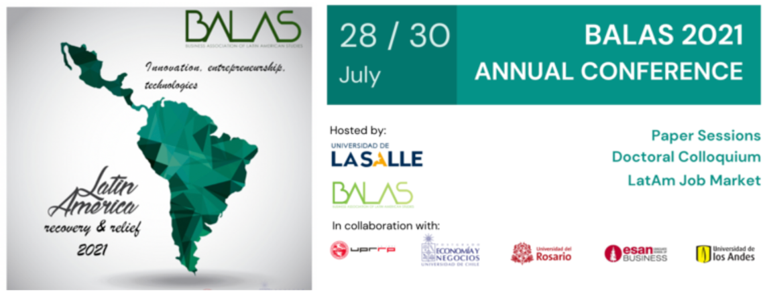
Instructions for entering the BALAS 2021 Annual Conference Online
- Before Conference Login: IF YOU ARE AN AUTHOR, and you or one of your coauthors have to be registered for the conference in the BALAS.org website. Please register at: https://balas.org/event-4164991/Registration with the same email.

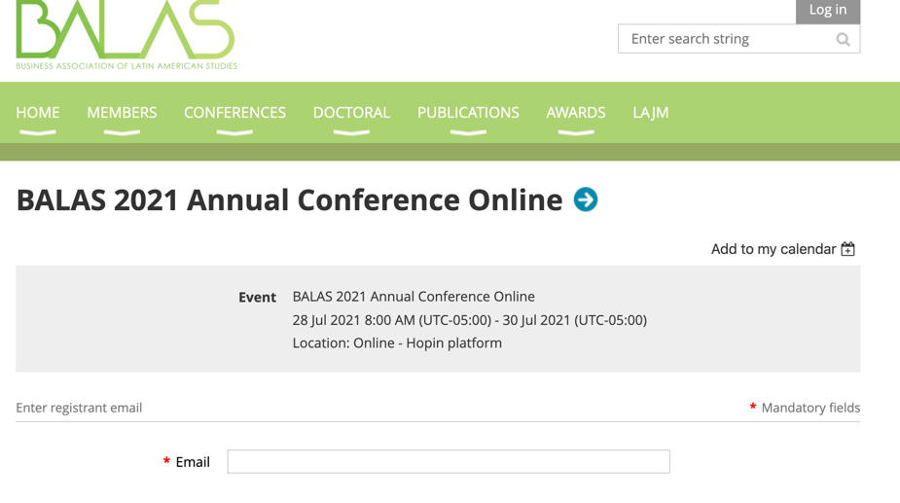
IMPORTANT: REGISTRATION HONOR CODE. In order to be considered in the BALAS Program authors/ presenters should register for the conference. We use a Honor Code System.

- MAKE SURE YOU ARE USING Google CHROME browser, as other browsers have some security issues that do not allow for sharing features.

- After at least one author per paper has been registered in BALAS.org website, you can access the conference site. https://hopin.com/events/balas-2021-annual-conference-online .If you do not have a HOPIN account the platform will prompt you to create one with your email. Then you can access the conference site use the PASSCODE provided:
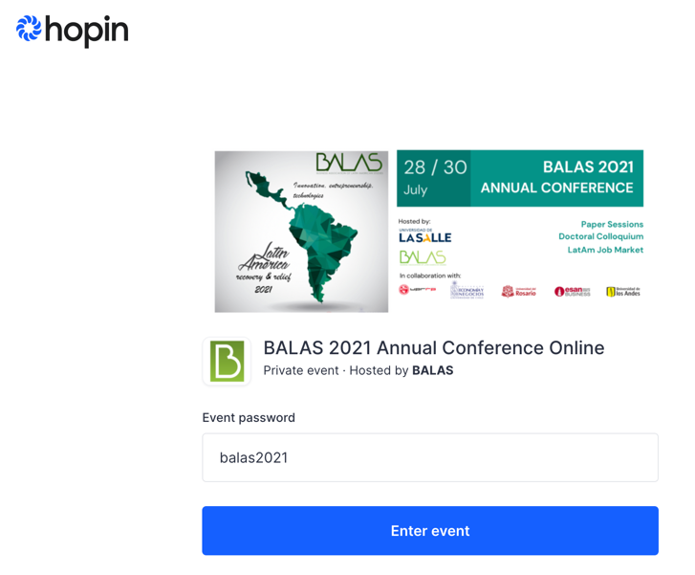
balas2021
- Please select the REGISTERED AUTHOR / PRESENTER ticket (Arrow 1) and hit the CHECKOUT button (Arrow 2). For other complimentary login (co-authors, students and professors, institutional reps., fellows), please select the corresponding ticket and then hit the CHECKOUT button.

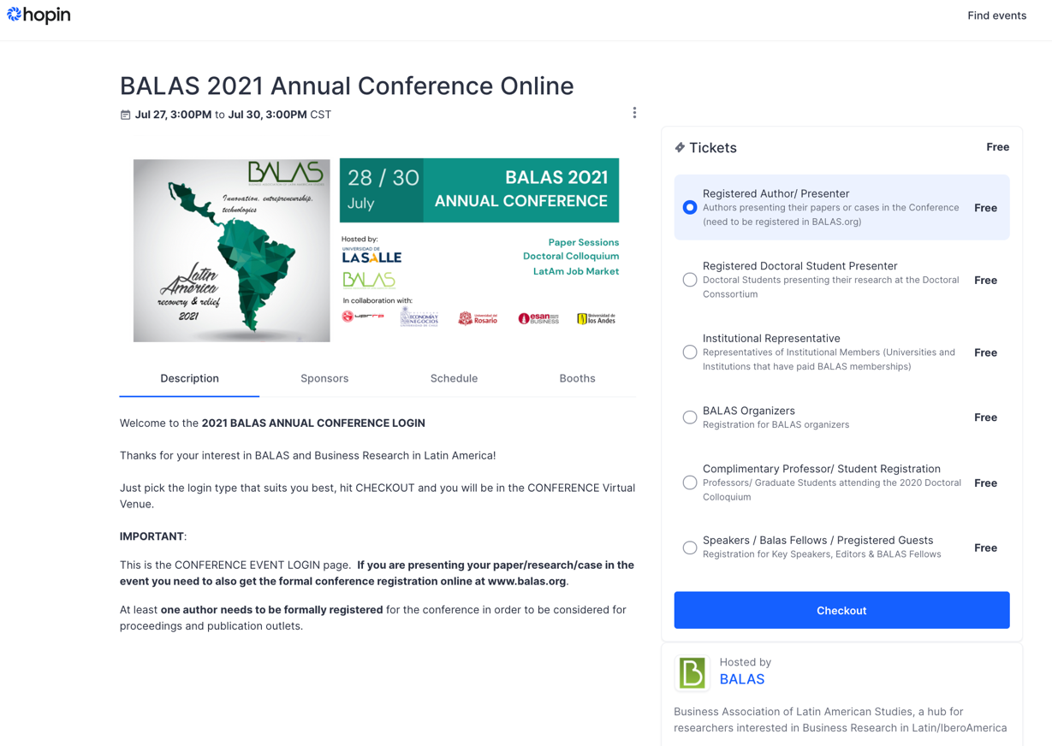
1
2
1
1
- IMPORTANT RECOMMENDATIONS

- The duration of your presentation is 12 minutes. At the end of it, you will have a 5-minutes round of questions and answers
- Please have your presentation open in pdf or ppt format (landscape format). Please avoid transitions in your presentation.
- You may send your presentation file to us: balasassociation@gmail.com, so we have it ready just in case you experience some technical or connection difficulties.
- In order to not to affect the quality of the video, a single presenter per manuscript will be allowed. Other co-authors may be present at the presentation but may not be able to present on screen.
- Remember to check your browser and make sure to use Google Chrome, the preferred browser.

Any inquiry? Please email us at: balasassociation@gmail.com
¡Welcome to the Balas2021 Online conference!

For complimentary login (co-authors, students and professors), PASSCODE: balas2021.

